NIP Project — Submission Document
Pega Platform project · Complete Submission Document (Version 2)

Section 1 — Your Details

Full Name | Chandradev M
Email ID (registered on NIP) | chandradevaravindh@gmail.com
Phone Number | 9344341778
College Name | V.S.B Engineering college,karur
Course | ECE
State | Tamil Nadu
Project Chosen | Vehicle Service Management Application
Pega Application Name | NIP-VehicleService-ChandradevM
Case Type Name (exact) | Cost Estimation
Pega Instance URL | https://z0xsgfed.pegacea.net/prweb/app/nip--vehicle-servic e--chandradevm/qCdJxG1hS7KOl96SgYaWBZvM3rTOhD Vk*/!STANDARD?pzPostData=-118219350
Operator Name | CHANDRADEVM@VEHICLE (Chandradev M)

Section 2 — Vehicle Service Management Application

Screenshot Rules Checklist:
- App Name: NIP-VehicleService-ChandradevM visible in screenshots.
- Operator Name (CHANDRADEVM@VEHICLE / Chandradev M) visible.
- Case ID & Student Name visible in running-case screenshots.

US-001 — Submit Vehicle Service Request
What is expected: Case created, customer submits Vehicle ID, Vehicle Model, Issue Description. Validation applied.
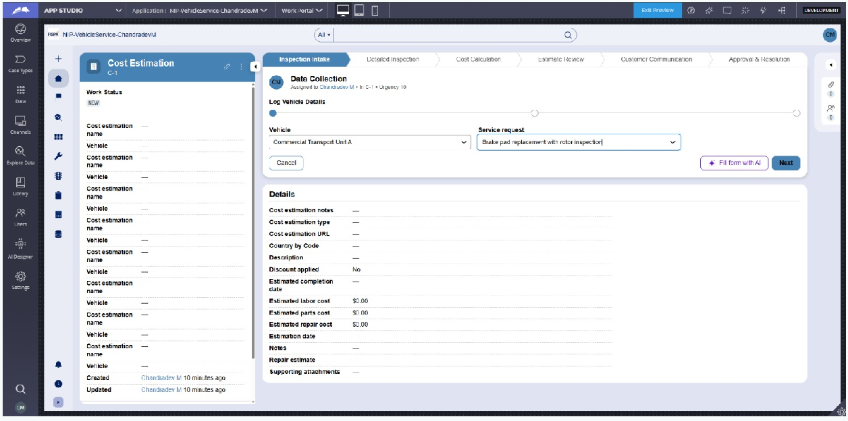

What I built for this: Configured the 'Log Vehicle Details' form view using Constellation layout with Data Reference fields for Vehicle and Service Request, ensuring proper validation upon case creation.

US-002 — Perform Vehicle Inspection

What is expected: Inspection stage with Service Advisor step. Inspection Notes and Condition Rating captured.
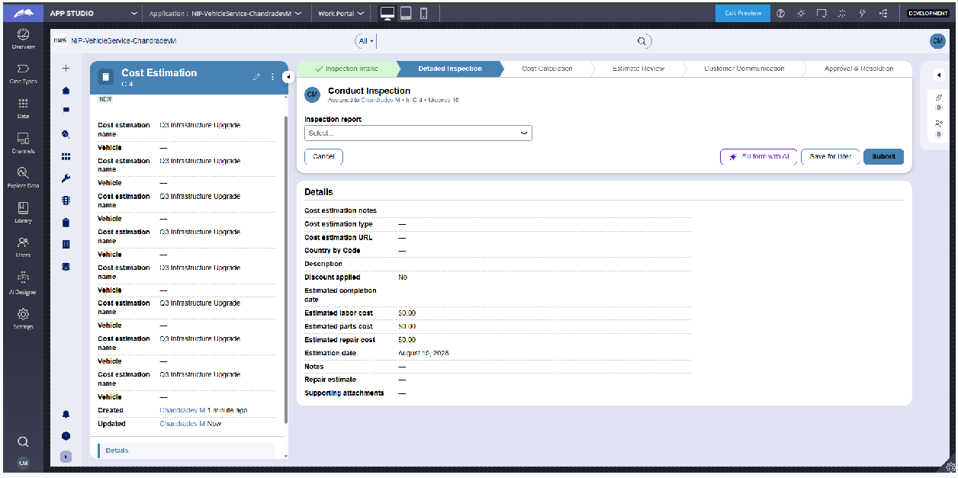

What I built for this: Added the Detailed Inspection stage with steps to conduct inspection, document findings, and capture vehicle condition images.

US-003 — Generate Service Estimate
What is expected: Labor Cost and Parts Cost captured. Total Cost calculated automatically by declare expression.

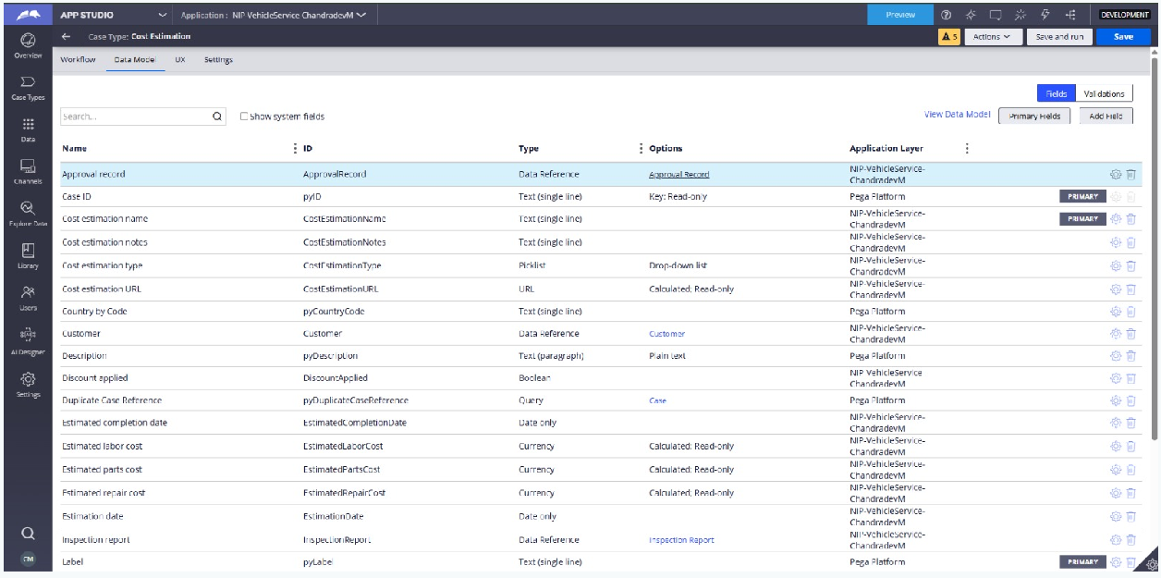

What I built for this: Created calculated currency properties (EstimatedLaborCost, EstimatedPartsCost, EstimatedRepairCost) to automatically compute total costs via Declare Expression.

US-004 — Approve Service Estimate
What is expected: Approval stage assigned to Customer. Approval Status captured. Flow branches on approve/reject.

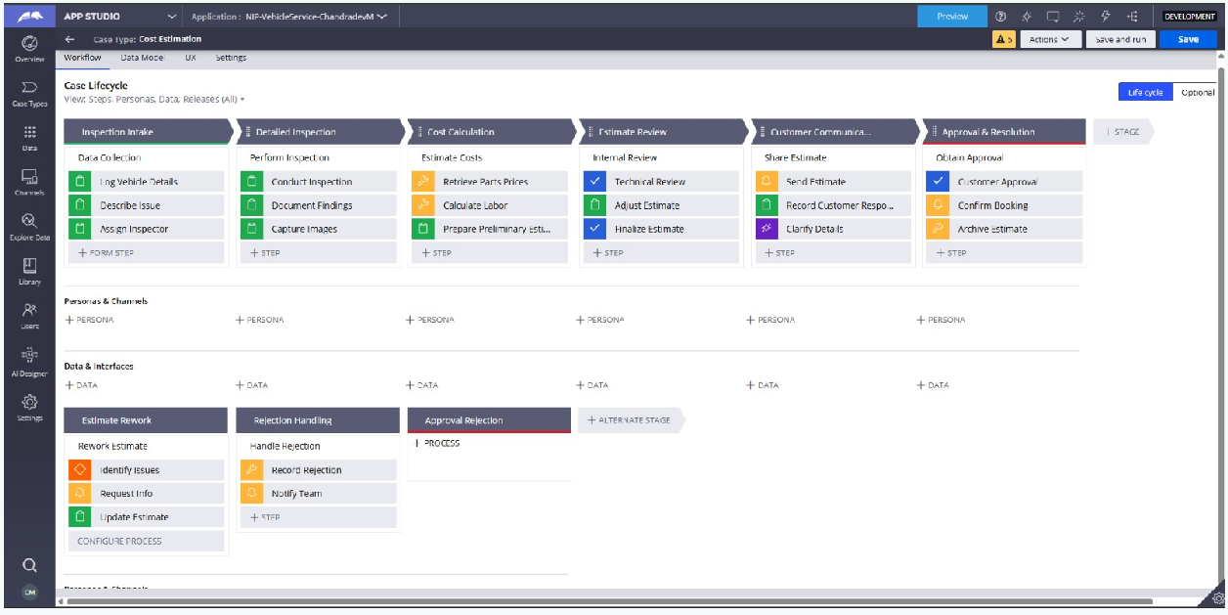

What I built for this: Configured the Approval & Resolution stage with a customer approval step and branching logic for rework or rejection handling.

US-005 — Maintain Vehicle Data
What is expected: Reusable Vehicle data object created with Vehicle ID, Model, Type — linked to case.
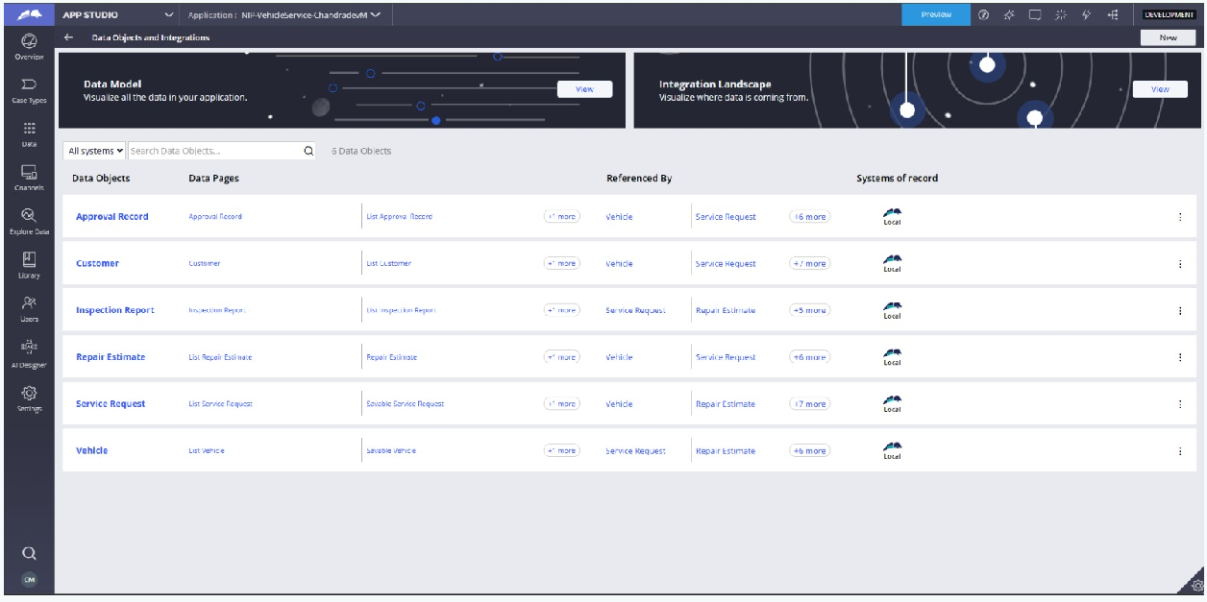

What I built for this: Built a reusable 'Vehicle' Data Object backed by a local system of record and linked it directly to the Cost Estimation case type.

US-006 — Review Service Estimate
What is expected: Approval screen shows Labor Cost, Parts Cost and Total Cost clearly to the Customer persona.
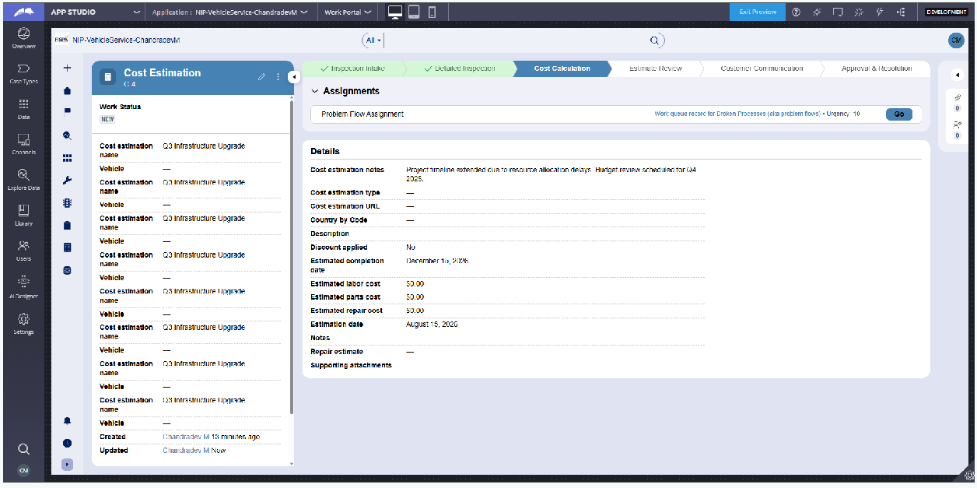

What I built for this: Designed the Internal Review step displaying itemized labor, parts, and total repair cost calculations to the user.

US-007 — Auto Assign Technician
What is expected: Service Execution stage with routing to HeavyVehicleQueue or LightVehicleQueue. Assigned Technician and Service Status properties maintained.

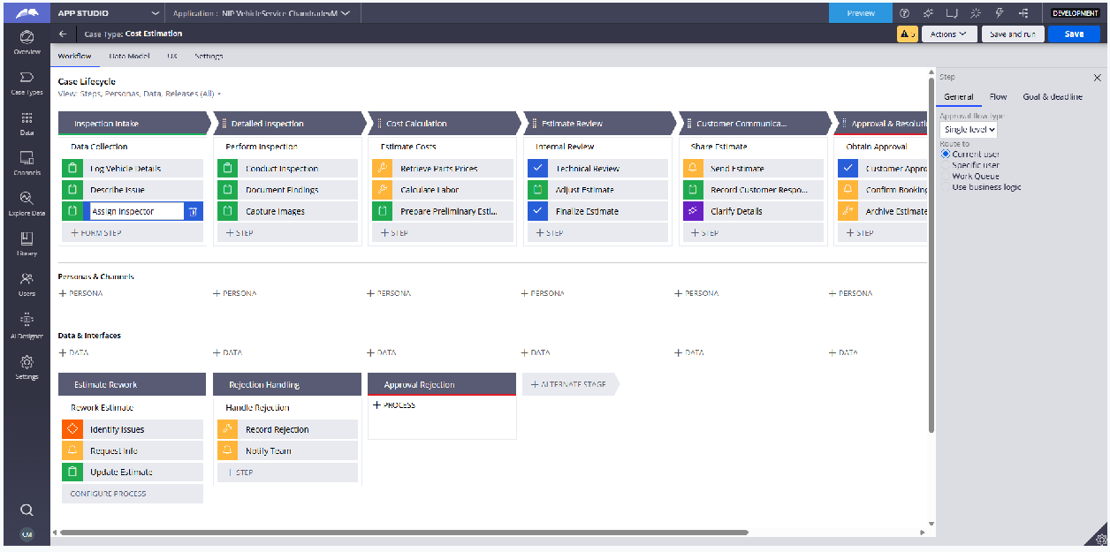

What I built for this: Set up routing logic to automatically dispatch cases to dedicated work queues (HeavyVehicleQueue/LightVehicleQueue) based on vehicle specifications.

US-008 — Notify Service Completion
What is expected: Correspondence rule created and triggered on case resolution. Email includes case and vehicle details.
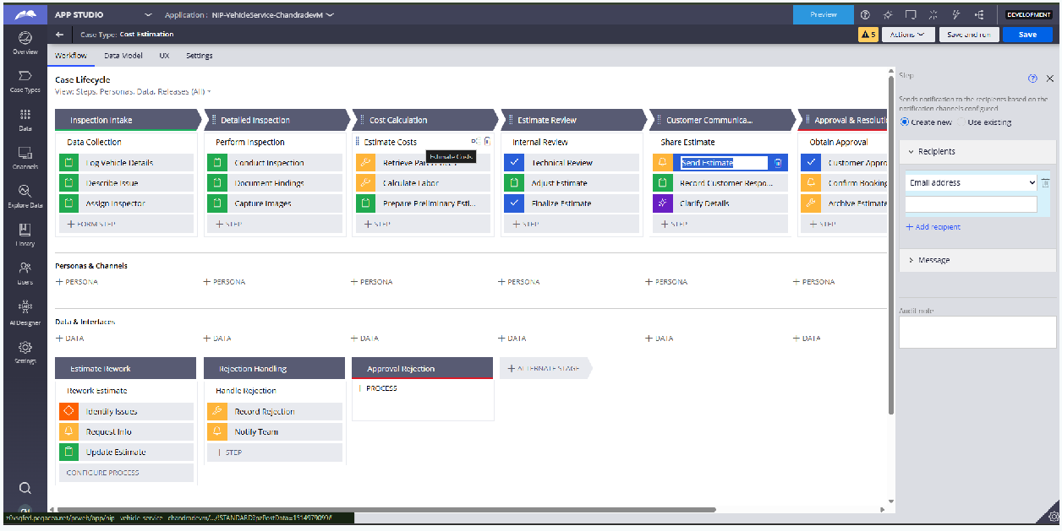

What I built for this: Created automated notification steps to send estimate details and completion alerts directly to the customer via correspondence rules.

US-009 — Define Service SLA
What is expected: SLA configured on the case type. Goal: 2 days. Deadline: 3 days. Priority increases on breach.
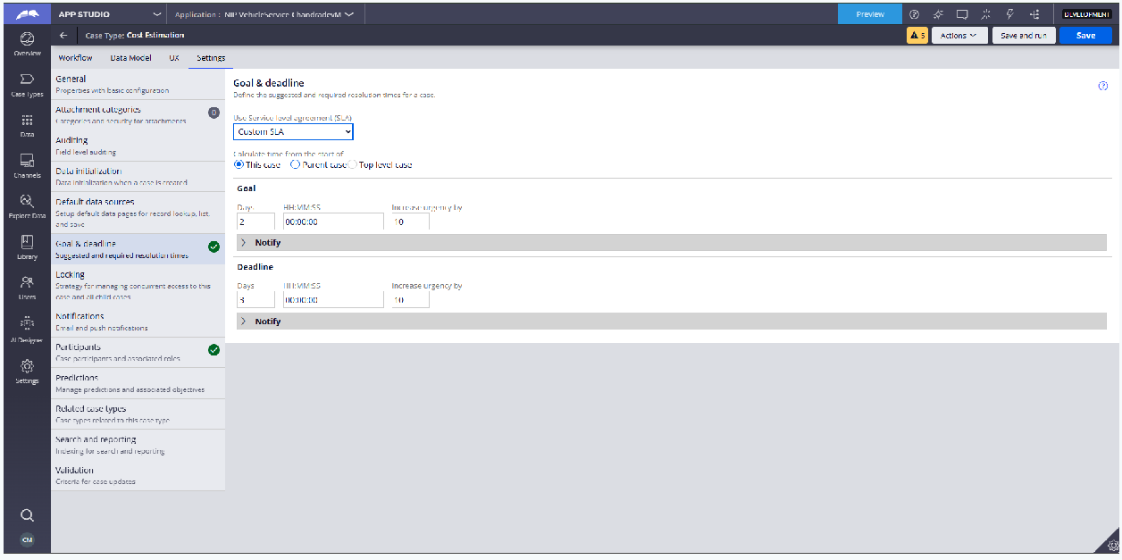

What I built for this: Configured SLA rules on the Cost Estimation case type specifying Goal (2 days) and Deadline (3 days) times with priority adjustments upon breach.

US-010 — Route by Vehicle Type
What is expected: Routing rule or Decision Table routes to HeavyVehicleQueue or LightVehicleQueue based on Vehicle Type property.

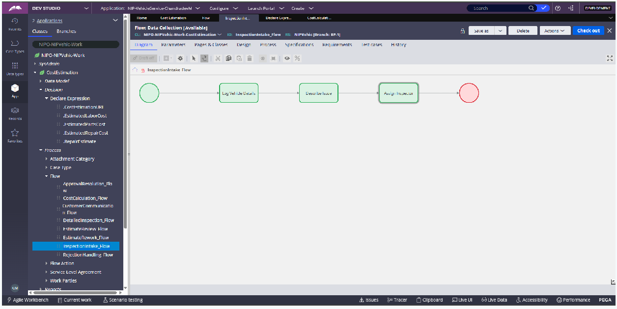

What I built for this: Built decision routing logic based on the Vehicle Type property to segregate heavy vs. light vehicle requests.

Section 3 — About Your Application

Q1. List your stages in the order they appear in your case lifecycle.
Inspection Intake, Detailed Inspection, Cost Calculation, Estimate Review, Customer Communication, Approval & Resolution, Estimate Rework (Alternate Stage), Rejection Handling (Alternate Stage), Approval Rejection (Alternate Stage)

Q2. Name the data object(s) you created and the properties inside them.
Data Objects Created: Vehicle, Service Request, Repair Estimate, Inspection Report, Customer, Approval Record.
Key Properties: VehicleID, Model, VehicleType, RegistrationNumber, IssueDescription, ServiceType, EstimatedLaborCost, EstimatedPartsCost, EstimatedRepairCost, EstimationDate, ApprovalStatus, CustomerName, CustomerEmail.

Q3. What is the exact name and type of the rule you used to calculate Total Cost?
- Rule Name: CalculateTotalCost
- Rule Type: Declare Expression
- Properties used: EstimatedLaborCost, EstimatedPartsCost
- Formula used: EstimatedRepairCost = EstimatedLaborCost + EstimatedPartsCost

Section 4 — Your Understanding

Q4. What did Blueprint generate for you, and what did you add or change yourself afterwards?
Blueprint generated the initial baseline case lifecycle stages (Inspection Intake, Cost Calculation, Customer Communication) and standard data properties. I customized the application by adding dedicated alternate stages (Estimate Rework, Rejection Handling), configured Constellation 2-column form views for vehicle logging, and created custom local data objects for Vehicle and Service Request.

Q5. Was there anything Blueprint created that you had to correct or configure further? Describe one example.
Yes. Blueprint initially created a generic single-column form view for vehicle intake that lacked structured links to external data. I reconfigured the View in App Studio to a clean 2-column layout and added Data References for both Vehicle and Service Request.

Q6. Explain your case flow from creation to resolution, in order.
- Creation: Customer/Service Advisor logs vehicle details and issue description in the Inspection Intake stage.
- Inspection: Technician conducts a physical check and records findings in Detailed Inspection.
- Calculation: Parts prices and labor costs are calculated automatically via Declare Expressions.
- Review & Communication: Advisor reviews the estimate and sends it to the customer.
- Approval/Resolution: Customer approves or rejects. Approved cases proceed to booking confirmation and archive; rejections route to alternate rework stages.

Q7. Pick two design choices you made in your application and explain why you made them.
  - Design Choice 1 (Reusable Data Objects): Implemented reusable 'Vehicle' and 'Service Request' Data Objects to decouple data structures from case types, enabling clean data management.
  - Design Choice 2 (Automated Cost Calculation): Used Declare Expressions for cost computation so that total estimate costs update dynamically whenever labor or parts prices change, preventing manual entry errors.

Q8. What was the hardest part, and how exactly did you fix it?
The most challenging part was configuring data page bindings between the Constellation form views and local data tables. I fixed it by accessing the Data Model tab in App Studio and correctly mapping Savable Data Pages for Vehicle and Service Request.

Q9. If the approval step was only needed when Total Cost is above a certain amount,

what would you change in your application?
I would insert a Decision step / Gateway condition prior to the Customer Approval stage evaluating `EstimatedRepairCost > [Threshold]`. If true, the case routes to Customer Approval; otherwise, it skips approval and proceeds directly to Resolution.

Q10. List three exact rule names from your application that you personally created or modified.
- LogVehicleDetails — Form View / User Action
- CalculateTotalCost — Declare Expression
- Vehicle — Data Object

Q11. List all personas used in your application.
Customer, Service Advisor, Inspector, Technician, Manager

Q12. List all work queues used in your application and explain when each one is used.
- HeavyVehicleQueue: Used to route complex inspection and service cases involving heavy commercial vehicles.
- LightVehicleQueue: Used to route standard service and routine maintenance cases for light consumer vehicles.

